

Planning Proposal

* Amend the Land Zoning Map for all of Lot 684 and 685 DP 728405, Lot 644 DP 755503 & Lot 2 DP 1191803, 1 Kamilaroi Highway Gunnedah, from RE1 *Public Recreation* & SP2 *Infrastructure* to IN1*General Industrial.*
* Amend the Floor Space Ratio for all of Lot 684 and 685 DP 728405, Lot 644 DP 755503 & Lot 2 DP 1191803, 1 Kamilaroi Highway Gunnedah to 0.6:1.

Prepared by

Gunnedah Shire Council

20 March 2015

**PART 1 – OBJECTIVES OR INTENDED OUTCOMES OF THE PROPOSED LEP**

The objectives or intended outcomes of the Planning Proposal are as follows:

* Amend the Lot Size Map for all of Lot 684 DP 728405, Lot 685 DP 728405, Lot 644 DP 755503 & Lot 2 DP 1191803, 1 Kamilaroi Highway Gunnedah, from RE1 *Public Recreation* & SP2 *Infrastructure* to IN1 *General Industrial*.

The proposed amendment aims to achieve the redevelopment of the former livestock market centre for industrial development, on land containing existing utility connection and similar to adjacent land uses.

**PART 2 – EXPLANATION OF PROVISIONS TO BE INCLUDED IN THE PROPOSED LEP**

The objectives or intended outcomes of the Planning Proposal are to be achieved by amending the Gunnedah LEP 2012 Land Zoning Map (LZN_005AA) for the subject site in accordance with the proposed zoning map shown in appendix 4.

# PART 3 – JUSTIFICATION

**Section A – The need for the Planning Proposal.**

***1. Is the Planning Proposal a result of any strategic study or report?***

This Planning Proposal does not form part of any strategic report or study. The subject site contains the former Gunnedah Livestock Market Centre and until recently was owned by the State of New South Wales (Crown Lands). The site has not been used for the sale of livestock for quite some years, resulting in its sale. Council has since received an application on behalf of the new owner to rezone of the subject site to IN1 *General Industrial*.

Council’s Commercial and Industrial Land-use Strategy highlights that with the potential changes to the regional economic context, it is likely that demand for additional industrial land will come from the underlying base level and additional industrial businesses to service future mining activity in Gunnedah.

Council’s Economic Development Strategy outlines that there is approximately 165 hectares of industrial zoned land identified as being available for development. Of this land, the majority is located within the North West Industrial Park (Blackjack Road) precinct. The Strategy highlighted a number of constraints which are inhibiting the development of this land. The Strategy identified that in order to meet the estimated required industrial land in Gunnedah over the 2012-2022 period, the North West Industrial Park would need to be brought on-line.

The New England – North West Region Action Plan (2012) also recognised that the mining sector will have an impact on regional and local economies with a need to provide infrastructure and services to capitalise on emerging opportunities. A key priority in achieving this is industry diversification, business growth and job creation.

To ensure that Gunnedah is able to take advantage of mining related business development, the proposed rezoning is supported. The site offers additional land for development, which has established sewer, water and power utility supply. The site is located on the fringe of the Gunnedah business zone and adjacent to the western gateway off the Kamilaroi Highway.

With the proposed confluence of the Oxley and Kamilaroi Highways at the intersection with Warrumbungle Street in 2016 this site does have great strategic significance for use approvable within the General Industrial Zone.

***2. Is the planning proposal the best means of achieving the objectives or intended outcomes, or is there a better way?***

It is believed the amendment of Gunnedah LEP 2012 Land Zoning Map (LZN_005AA) for the subject land is the best means of achieving the intended outcomes of this Planning Proposal.

***Section B – Relationship to strategic planning framework.***

***3. Is the planning proposal consistent with the objectives and actions of the applicable regional or sub-regional strategy (including the Sydney Metropolitan Strategy and exhibited draft strategies?)***

The Namoi 2030 Regional Resource Strategy was a joint initiative between Councils in the Namoi catchment for the purpose of producing a regional land use management strategy with a focus on sustainable growth. The report refers to the current and projected growth of the Gunnedah region, in particular the anticipated growth in resource development and the impact this will have on supporting industries.

The Planning Proposal will provide additional industrial land to cater for the expected growth in support industries.

***4. Is the planning proposal consistent with Council’s local strategy or other local strategic plans?***

Council’s Community Strategic Plan identifies the value of building the Shire’s economy, and in particular the potential impacts of mining. The Planning Proposal aims to enable the provision of industrial zoned land with existing utility connection, which would benefit the Shire’s population, job growth, and economy.

Council’s Commercial and Industrial Land-use Strategy identifies there is an existing shortage of industrial land within Gunnedah Shire and an even greater shortage of industrial zoned land with existing utility connection. The Planning Proposal aims to enable the provision of industrial zoned land with existing utility connection, which would benefit the Shire’s population, job growth, and economy.

***5. Is the planning proposal consistent with applicable State Environmental Planning Policies?***

*The Planning Proposal is considered to be consistent with applicable State Environmental Planning Policies (refer to Appendix 1).*

***6. Is the planning proposal consistent with relevant Ministerial Directions (s.117 directions)?***

The Planning Proposal is considered to be consistent with all the applicable S.117 Ministerial Directions, with the exception of 2.1 Environmental Protection Zones, 2.3 Heritage Conservation, 3.2 Parks and Manufactured Home Estates, 3.3 Home Occupations, 3.4 Integrating Land Use and Transport, and 6.2 Reserving Land for Public Purposes

***Section C – Environmental, Social and economic impact***

***7. Is there any likelihood that critical habitat or threatened species, populations or ecological communities, or their habitats, will be adversely affected as a result of the proposal?***

The Planning Proposal notes no known threatened vegetation or ecological communities; however the application notes the site does contain White Box (Eucalyptus albens), which is an endangered species. The subject site is heavily modified, consisting of mostly vacant land, three Peppercorn trees (Schinnus molle) and two White Box trees (Eucalyptus albens). If the two White Box trees are required to be removed a full assessment of likely impacts would be undertaken during the development application stage, which will include an assessment under SEPP 44 – Koala Habitat Protection.

***8. Are there any other likely environmental effects as a result of the planning proposal and how are they proposed to be managed?***

It is highly unlikely the planning proposal will result in any other likely environmental effects such as natural hazards, flooding or landslip. The subject site if not identified as bushfire prone or flood prone land according to Council’s mapping data. The site is relatively flat, thus highly unlikely to be susceptible to landslip. Should the Planning Proposal proceed, any other likely environmental effects will be assessed at the Development Application stage.

***9. Has the planning proposal adequately addressed any social and economic effects?***

It is expected the Planning Proposal will result in a positive social and economic outcome as it will increase the provision of industrial zoned land with existing utility connection in Gunnedah.

Provisions for the conservation and management of Aboriginal and European heritage already exist within the current LEP. Should the Planning Proposal proceed, assessment of any impacts will be undertaken at the Development Application stage.

***Section D – State and Commonwealth Interest***

***10. Is there adequate infrastructure for the planning proposal?***

The Planning Proposal is expected to have a similar impact on existing infrastructure as industrial development carried out under the current development standards. New infrastructure required as a result of future site development will be required to to be provided in a similar manner and in accordance with Council’s requirements.

***11. What are the views of state and commonwealth public authorities consulted in accordance with the gateway determination?***

Depending on agencies identified in the Gateway Determination***,*** it is proposed consultation should be undertaken with the following state and commonwealth public authorities.

*Roads and Maritime Services (RMS)* – Identify potential need for augmentation of Kamilaroi Highway/ Stockman Close intersection

**PART 4 – MAPPING**

The planning proposal relates to an amendment of Gunnedah LEP 2012 Land Zoning Map (LZN_005AA). Preliminary plans have been attached to this Planning Proposal in attachments three and four.

**PART 5 – COMMUNITY CONSULTATION**

It is proposed to exhibit the Planning Proposal on Council’s website and Administration Centre for fourteen days, with notice of the public exhibition being given:

* In a newspaper that circulates in the area affected by the Planning Proposal – the Namoi Valley Independent, and
* On Council’s website, [www.gunnedah.nsw.gov.au](http://www.gunnedah.nsw.gov.au)

**PART 6 – PROJECT TIMELINE**

The table below provides an indication of the timeline for the Planning Proposal.

|  |  |
| --- | --- |
| **Anticipated commencement date (date of Gateway determination)** | April 2015 upon receipt of Gateway Determination. |
| **Anticipated timeframe for the completion of technical information** | Technical studies have not been identified as a component of the planning proposal. The Department of Planning and Infrastructure may make prescriptions relating to technical information. |
| **Timeframe for government agency consultation (pre and post exhibition as required by Gateway determination)** | April 2015  Subject to requirements of Gateway Determination, agency consultation would occur during the public consultation phase. |
| **Commencement and completion dates for public exhibition period** | 3 – 17 April 2015 |
| **Dates for public hearing (if required)** | Not identified as being required. |
| **Timeframe for consideration of submissions** | Three weeks. |
| **Timeframe for the consideration of a proposal post exhibition** | Four weeks (partially in conjunction with considerations of submissions) |
| **Date of submission to the Department of Parliamentary Counsel to finalise LEP** | 24 May 2015 |
| **Anticipated date RPA will make the plan (if delegated)** | July 2015 |
| **Anticipated date RPA will forward to department for notification** | July 2015 |

**Appendix 1 – Consideration of applicable SEPP relative to Draft Gunnedah LEP 2012 (Amendment No. 7)**

|  |  |  |  |
| --- | --- | --- | --- |
| **SEPP** | **Applicable** | **Consistent** | **Comments** |
| **No. 1 – Development Standards** | No | N/A | Not applicable to Planning Proposal |
| **No. 21 – Caravan Parks** | No | N/A | Not applicable to Planning Proposal. |
| **No. 30 – Intensive Agriculture** | No | N/A | Not applicable to Planning Proposal |
| **No. 32 – Urban Consolidation (Redevelopment of Urban Land)** | No | N/A | Not applicable to Planning Proposal |
| **No. 33 - Hazardous and Offensive Development** | No | N/A | Not applicable to Planning Proposal |
| **No 36 – Manufactured Estate Homes** | No | N/A | Not applicable to Planning Proposal |
| **No. 44 – Koala Habitat Protection** | Yes | Inconsistent | The subject site is heavily modified, containing only 5 trees, two of which are koala habitat trees. As this equates to more than 15% koala habitat trees, the site could be considered ‘*potential koala habitat’.* Given the existing level of clearing of the site, its location within the Gunnedah township, and its area being less than 1 hectare, it is considered this is highly unlikely.  In this respect, this inconsistency is considered to be of minor significance. |
| **No. 50 – Canal Estate Development** | No | N/A | Not applicable to Planning Proposal |
| **No. 55 – Remediation of Land** | Yes | Consistent | NSW Soil Conservation Service assessment deems the site to contain no contamination. Refer to Appendix 6. |
| **No. 62 – Sustainable Aquaculture** | No | N/A | Not applicable to Planning Proposal |
| **No. 64 – Advertising and Signage** | No | N/A | Not applicable to Planning Proposal |
| **No. 65 – Design Quality of Residential Flat Buildings** | No | N/A | Not applicable to Planning Proposal |
| **Affordable Rental Housing 2009** | No | N/A | Not applicable to Planning Proposal |
| **Building Sustainability Index: BASIX 2004** | No | N/A | Not applicable to Planning Proposal |
| **Exempt and Complying Development Codes 2008** | No | N/A | Not applicable to Planning Proposal |
| **Housing for Seniors or People with a Disability 2004** | No | N/A | Not applicable to Planning Proposal |
| **Infrastructure 2007** | No | N/A | Not applicable to Planning Proposal |
| **Major Development 2005** | No | N/A | Not applicable to Planning Proposal |
| **Mining, Petroleum Production and Extractive Industries 2007** | No | N/A | Not applicable to Planning Proposal |
| **Miscellaneous Consent Provision 2007** | No | N/A | Not applicable to Planning Proposal |
| **Rural Lands 2008** | No | N/A | Not applicable to Planning Proposal |
| **State and Regional Development 2012** | No | N/A | Not applicable to Planning Proposal |

**Appendix 2 – Consideration of Section 117 Ministerial Directions – Assessment relative to Gunnedah LEP 2012 (Amendment No. 7)**

1. **Employment and Resources**

|  |  |  |  |
| --- | --- | --- | --- |
| **Direction** | **Applicable** | **Consistent** | **Reason for inconsistency or comment** |
| * 1. Business and Industrial zones | Yes | Consistent | The Planning Proposal gives effect to the aims of this direction as it provides the opportunity for the provision of industrial zoned land containing existing utility connection. |
| * 1. Rural Zones | No | Not applicable | Not applicable to Planning Proposal. Subject site is not located in or near a rural zone. |
| * 1. Mining, Petroleum Production and Extractive Industries | No | Not applicable | Not applicable to Planning Proposal.  Planning proposal will not restrict the potential for development of resources. |
| * 1. Oyster Aquaculture | No | Not applicable | This direction is not applicable to the LGA. |
| * 1. Rural Lands | No | Not applicable | Not applicable to Planning Proposal. Planning Proposal is not or rural nature. Subject site is not located in or near a rural zone. |

1. **Environment and Heritage**

|  |  |  |  |
| --- | --- | --- | --- |
| **Direction** | **Applicable** | **Consistent** | **Reason for inconsistency or comment** |
| * 1. Environmental Protection Zones | Yes | Inconsistent | The planning proposal does not include provisions to facilitate the protection and conservation of environmentally sensitive areas as these provisions already exist in the current instrument. In this respect, this inconsistency is considered to be minor significance. |
| * 1. Coastal Protection | No | Not applicable | This Direction is not applicable to the LGA. |
| * 1. Heritage Conservation | Yes | Inconsistent | The planning proposal does not contain provisions for the conservation and management of heritage items as these provisions already exist in the current instrument. In this respect, this inconsistency is considered to be of minor significance. |
| * 1. Recreation Vehicle Areas | Yes | Consistent | The permissibility of the land-use for recreational vehicles is not increased or affected by the planning proposal. |

1. **Housing, Infrastructure and Urban Development**

|  |  |  |  |
| --- | --- | --- | --- |
| **Direction** | **Applicable** | **Consistent** | **Reason for inconsistency or comment** |
| * 1. Residential Zones | No | Not applicable | Not applicable to Planning Proposal. |
| * 1. Parks and Manufactured Home Estates | Yes | Inconsistent | The planning proposal does not include provisions for caravan parks and manufactures home estates as these provisions already exist in the current instrument and Council’s DCP. *SEPP 21 (Caravan Parks)* & *SEPP 36 (Manufactured Home Estates)* are applicable to the subject land and prevail over the *GLEP 2012.*In this respect, this inconsistency is considered to be of minor significance. |
| * 1. Home Occupations | Yes | Inconsistent | The planning proposal does not contain provisions for home occupations as these provisions already exist in the current instrument. In this respect, this inconsistency is considered to be of minor significance. |
| * 1. Integrating Land Use and Transport | Yes | Inconsistent | The planning proposal does not include provisions for integrated land-use and transport as these provisions already exist in the current instrument. In this respect, this inconsistency is considered to be of minor significance. |
| * 1. Development Near Licensed Aerodromes | No | Not applicable | Not applicable to Planning Proposal. Subject site is not located near a licensed aerodrome. |
| * 1. Shooting Ranges | No | Not applicable | This Direction is not applicable to the planning proposal. Subject site is not located near a licensed shooting range. |

1. **Hazard and Risk**

|  |  |  |  |
| --- | --- | --- | --- |
| **Direction** | **Applicable** | **Consistent** | **Reason for inconsistency or comment** |
| * 1. Acid Sulphate Soils | No | Not applicable | This direction is not applicable to the LGA. |
| * 1. Mine Subsidence and Unstable Land | No | Not Applicable | This direction is not applicable to the LGA. |
| * 1. Flood Prone Land | No | Not applicable | Not applicable to Planning Proposal. Subject site is not mapped as flood prone land according to Councils Flood Prone Land Map. |
| * 1. Planning for Bushfire Protection | No | Not applicable | Not applicable to Planning Proposal. Subject site is not mapped as Bushfire prone land according to Councils Bushfire Prone Land Map. |

1. **Regional Planning**

|  |  |  |  |
| --- | --- | --- | --- |
| **Direction** | **Applicable** | **Consistent** | **Reason for inconsistency or comment** |
| * 1. Implementation of Regional Strategies | No | Not applicable | This direction is not applicable to the Gunnedah Shire LGA. |
| * 1. Sydney Drinking Water Catchments | No | Not applicable | This direction is not applicable to the Gunnedah Shire LGA. |
| * 1. Farmland of State and Regional Significance on the NSW Far North Coast | No | Not applicable | This direction does not apply to the Gunnedah Shire LGA. |
| * 1. Commercial and Retail Development along the Pacific Highway, North Coast | No | Not applicable | This direction is not applicable to the Gunnedah Shire LGA |
| 5.8 Second Sydney Airport: Badgery’s Creek | No | Not applicable | This direction is not applicable to the Gunnedah Shire LGA. |
| * 1. North West Rail Link Corridor Strategy | No | Not applicable | This direction is not applicable to the Gunnedah Shire LGA. |

1. **Local Plan Making**

|  |  |  |  |
| --- | --- | --- | --- |
| **Direction** | **Applicable** | **Consistent** | **Reason for inconsistency or comment** |
| * 1. Approval and Referral Requirements | Yes | Consistent | The planning proposal does not include provisions that require concurrence, consultation or referral of development applications to the minister. |
| * 1. Reserving Land for Public Purposes | Yes | Inconsistent | The planning proposal involves rezoning an allotment currently zoned RE1 *Public Recreation*. The allotment proposed to be rezoned is part of a dual allotment parcel of land, separated by Stockman Close (Lot 1 & 2 DP 1191803). The allotment proposed to be rezoned (Lot 2) is located on the southern side of Stockman Close and is vacant land, containing an existing access to the subject site, therefore not meeting the objectives of the zone. Lot 1 is located on the northern side of Stockman Close and contains trees and public garbage bins, therefore meeting the objectives of the zone. It is proposed this allotment will retain its current zoning. As Lot 1 does not currently meet the objectives of the zone. In this respect, it is considered this inconsistency is of minor significance. Refer to Appendix 5. |
| * 1. Site Specific Provisions | Yes | Consistent | The planning proposal aims to rezone the subject site to a zone currently existing in the Gunnedah LEP 2012. The rezoning will allow the proposed land use without imposing any additional development standards or requirements in addition to those contained in that zone. |

1. **Metropolitan Planning**

|  |  |  |  |
| --- | --- | --- | --- |
| **Direction** | **Applicable** | **Consistent** | **Reason for inconsistency or comment** |
| * 1. Implementation of the Metropolitan Plan for Sydney 2036 | No | Not applicable | This direction is not applicable to the LGA. |

**Appendix 3 – Current Land zoning Map**

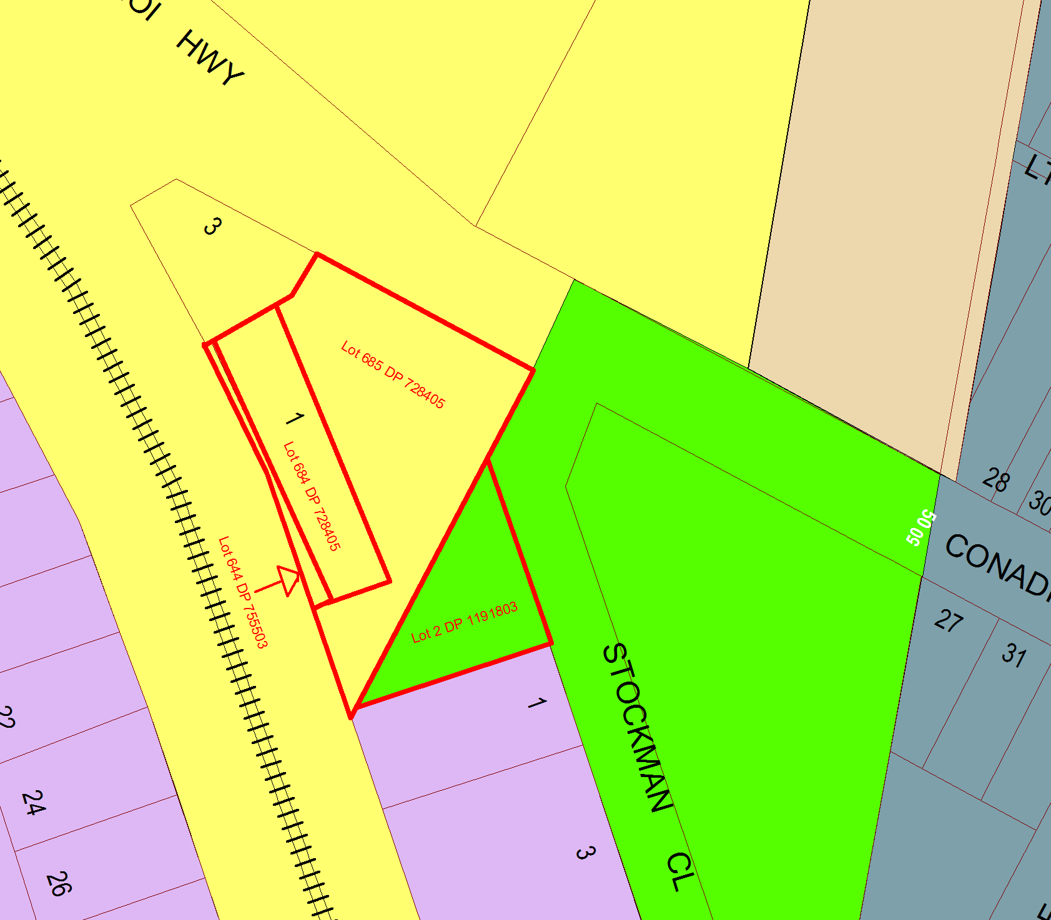

**Appendix 4 – Proposed Land Zoning Map**

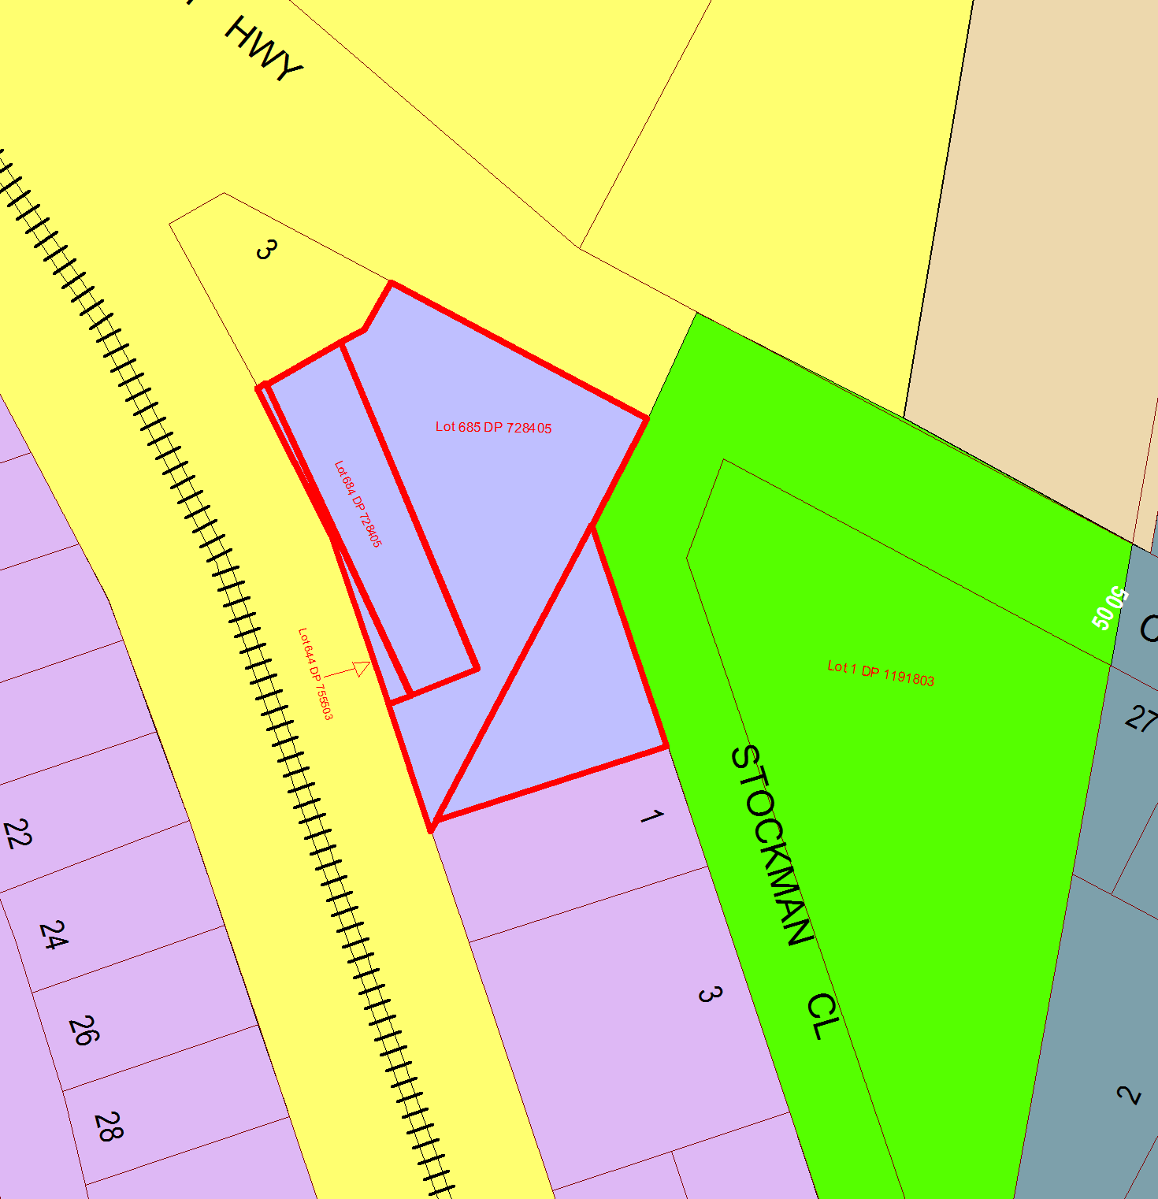

Lot 2 DP 1191803

**Appendix 5 – Arial photograph of Public land proposed to be rezoned**

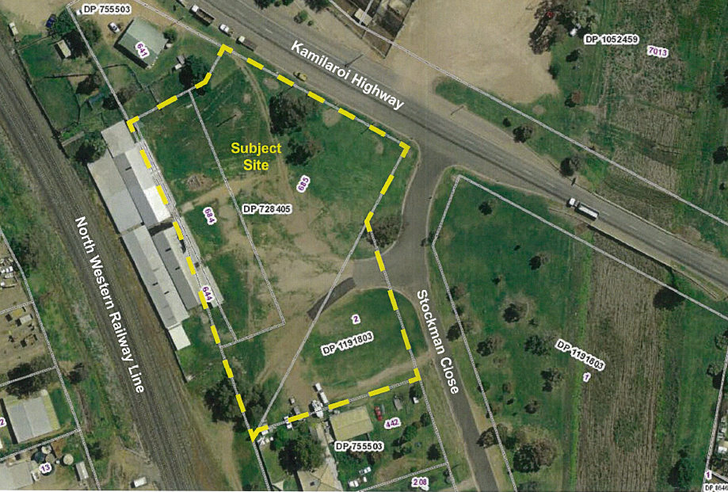

**Appendix 6 – Site Contamination Report prepared by the NSW Soil Conservation Service**